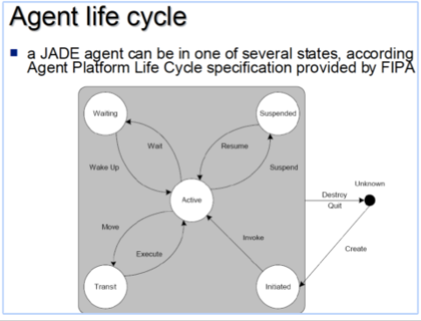

jade.core

**Class Agent**

* java.lang.Object
  + jade.core.Agent
* **All Implemented Interfaces:**

java.io.Serializable, java.lang.Runnable

**Direct Known Subclasses:**

[GatewayAgent](https://jade.tilab.com/doc/api/jade/wrapper/gateway/GatewayAgent.html), jade.gui.GuiAgent

public class Agent

extends java.lang.Object

implements java.lang.Runnable, [Serializable](https://jade.tilab.com/doc/api/jade/util/leap/Serializable.html)

The Agent class is the common superclass for user defined software agents. It provides methods to perform basic agent tasks, such as:

* **Message passing using ACLMessage objects, both unicast and multicast with optional pattern matching.**
* **Complete Agent Platform life cycle support, including starting, suspending and killing an agent.**
* **Scheduling and execution of multiple concurrent activities.**

Application programmers must write their own agents as Agent subclasses, adding specific behaviours as needed and exploiting Agent class capabilities.

**Version:**

$Date: 2017-05-23 10:41:19 +0200 (mar, 23 mag 2017) $ $Revision: 6826 $

**Author:**

Giovanni Rimassa - Universita' di Parma, Giovanni Caire - TILAB

**See Also:**

[Serialized Form](https://jade.tilab.com/doc/api/serialized-form.html#jade.core.Agent)